7COM1079-0901-2025 - Team Research and Development Project

Final report title: Goal Timing Analysis in Women's International Football Matches

Group ID: A 102

Dataset number: ds260

Prepared by: PAVAN KUMAR MUKKALA 24175973
VENKATA NARAYANA TANIKONDA 24136599
VISHAL MADHIRA 24076718
SUDHEER KUMAR KETHAVATH 24242280
VAISHNAVI KARI 23029286

University of Hertfordshire
Hatfield, 2025

Table of Contents

- Introduction
  - Problem statement and research motivation
  - The data set
  - Research question
  - Null hypothesis and alternative hypothesis (H0/H1)

- Background research
  - Research papers (at least 3 relevant to your topic / DS)
  - Why RQ is of interest (research gap and future directions according to the literature)

- Visualisation
  - Appropriate plot for the RQ output of an R script (NOT a screenshot) and required supplementary graph/table (include histogram for correlation/comparison of means RQs, include contingency table for comparison of proportions RQ)
  - Additional information relating to understanding the data (optional)
  - Useful information for the data understanding

- Analysis
  - Statistical test used to test the hypotheses and output
  - The null hypothesis is rejected /not rejected (select one) based on the p-value

- Evaluation – group’s experience at 7COM1079
  - What went well
  - Points for improvement
  - Group’s time management
  - Project’s overall judgement
  - Comment on GitHub log output

- Conclusions
  - Results explained.
  - Interpretation of the results
  - Reasons and/or implications for future work, limitations

- Reference list
Harvard (author, date) format.
- Appendices
- R code used for analysis and visualisation.
- GitHub log output.

1. Introduction

  - Problem statement and research motivation (100 words)
The awareness regarding goal timing in women international football may show the tendency of fatigability of players, change in tactics and errors in defense. Unintentional errors that constitute own goals can be done at various time intervals than ordinary goals because of growing pressure or fatigue. The motivation behind this research is the necessity to examine these temporal differences that can be put into use in coaching to reduce the number of errors. The literature focuses on goal-scoring habits and ignores the details of own-goals (Ibanez et al., 2024).
  - The data set (75 words)

The sample used is 2795 women international football goal (goal) data between 1984 and 2025. The major variables are date, nominal, home team and away team, nominal, team, nominal, scorer, nominal, minute, nominal (interval, 1-120), own_goal, nominal binary and penalty, nominal binary. It records such match information as goals and times, and through this, one can analyze goal patterns. The data is seen to be clean without any missing values following filtering.

  - Research question (50 words).

Is there a difference in the mean of minute (goal timing) between own goals and regular goals?

  - Null hypothesis and alternative hypothesis (H0/H1) (100 words)

The null hypothesis (H0) is that the mean of the minutes at which own goals are scored is the same as the mean of the minutes at which regular goals are scored in a match of women international football. This is given that there is no difference in timing giving an impression that one would not play own goals as they appear in ordinary instances.
The alternative hypothesis is (H1) The mean minute of scoring own goals does not equal the mean minute of scoring the regular ones in international women football matches. This indicates that there is a difference in time that could be attributed to different factors such as fatigue which could affect errors differently. Two-tailed test is the right one to identify any difference.

- Background research
  - Research papers (at least 3 relevant to your topic / DS) (200 words)
Science and Medicine in Football.
Martinez-Hernandez et al. (2024) investigated movements before goal-scoring situations in the Women's Super League 2018/2019 of the football season using time-motion analysis. They detected linear advancing movement (walking, jogging, running or sprinting) as the most frequent movement performed (37% by attackers, 32.7% by defenders), followed by moves of deceleration and turns, which were preferred by attackers (sustained play with low intensity of cuts made), and defensemen (ball blocking and kicks at high intensity), despite the detailed examination of temporal patterns of mistakes such as own goal was not deeply investigated.
Sustainability in Sports Science Journal
Mesquita et al. (2023) examined 174 goals by elite French and English women's teams and found that most goals were active from offensive organization (highest percentage), but also featured in set pieces. Submissions peaked in the penalty area and times were grouped to score in 31-61 minutes - proof of scheme of play but little emphasis on error induced goals including own goal in time periods.
Biology of Sport
Sanmiguel-Codina et al. (2025) studied 95 goals from the UEFA Women's EURO 2022 and found that assists were most common from lateral corridors running outside penalty area (23.2%) and shots from the goal line projection to the penalty spot (48.2%). Half of them involved aerial balls with leg finishes and first contact shots being dominant, but the study made a call for more to be said about defensive mistakes and time in high-stakes matches.
  - Why RQ is of interest (research gap and future directions according to the literature) (100 words)

The gap in literature that the RQ aims to fill is that goal timing has been researched on a large scale, whereas less is known about the specifics of own-goal. Defensive errors are reported to have been on the rise later but were not compared with own-goal minutes. It is interesting in determining periods of errors. Future perspectives are the incorporation of fatigue measures or AI in predictive models during female football training.

- Visualisation
  - Appropriate graphs for the RQ (50 words)
The use of the boxplot was aimed to compare the distributions of minutes by the own-goal status with emphasizing the medians and outliers. It is appropriate in comparing the means RQs by displaying differences in central tendency.
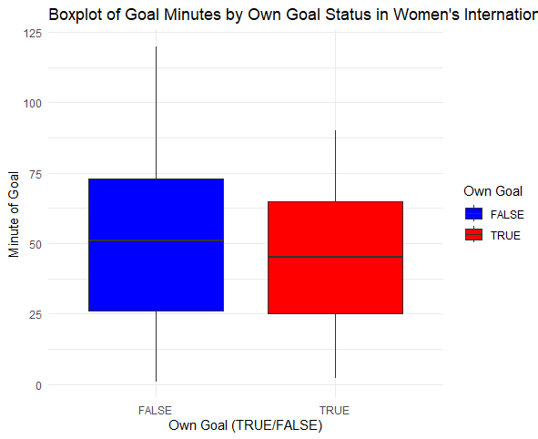
Output from ggplot code, title: "Boxplot of Goal Minutes by Own Goal Status in Women's International Football", x: "Own Goal (TRUE/FALSE)", y: "Minute of Goal", fill: "Own Goal"
Supplementary histograms display minute distributions for regular and own goals.
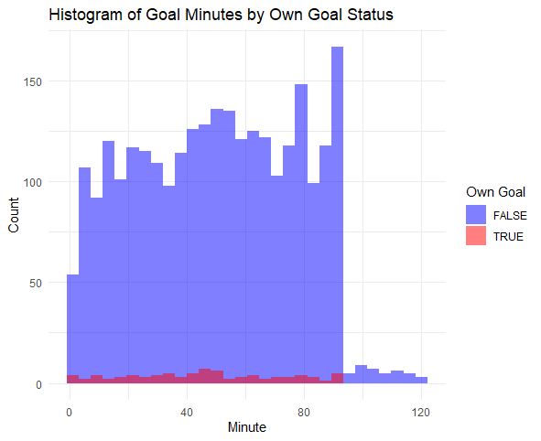
Title: "Histogram of Goal Minutes by Own Goal Status", x: "Minute", y: "Count", fill: "Own Goal"

  - Additional information relating to understanding the data (optional) (50 words)
The distribution peaks are smoothed using the density plot, and one can identify the regular goals with maximum distributions at 45-50 minutes, and the own goal with maximum distributions at slightly lower, which helps in identifying multimodal distributions.
[Insert Density Plot here: Title: "Density Plot of Goal Minutes by Own Goal Status", x: "Minute", y: "Density", color: "Own Goal"]

  - Useful information for the data understanding (50 words)
Noteworthy observations: The peaks of regular goals are in the middle of the match (mean 49.86), own goals at the start (mean 45.79). Share of personal objectives is 2.93, which is slightly growing with age. Home teams have more points (1608 vs 1187 away), equal rates of own goals.

- Analysis
  - Statistical test used to test the hypotheses and output (75 words)
Wilcoxon rank sum test was chosen as an alternative non-parametric form of t-test which is used to compare the mean when normality is not guaranteed (regular goals p<2.2e-16). It is a location shift test that is non-parametric.
Output: W = 120785, p-value = 0.1845.

  - The null hypothesis is rejected /not rejected based on the p-value (100 words)
The p -value =0.1845> = 0.05 and hence we reject H0. The evidence to indicate a difference in average between own, and regular goals, is not provided. It means that own goals are subject to similar timings as regular ones, and may not be distinctly related to late-game fatigue. The level of confidence in the outcomes is moderate because of the sample imbalance (82 own and 2713 regular).

- Evaluation – group’s experience at 7COM1079
  - What went well (75 words)

The collaboration within the team was good, and meetings were frequent, which ensured that there was task division. The data interpretation and R scripting went through well giving clear visualizations. The outcome of presentation was used to refine our RQ. Generally, we were able to be professional and honest to module values.

  - Points for improvement (75 words)

More regular communication might be over GH issues. We did not allocate enough time in reviewing literature and did not take enough time to create a summary hastily. Improved preparation of normality tests would have made analysis decisions easier.

  - Group’s time management (50 words)

Our weekly assignments were planned but the cleaning of the data was delayed. Time was lost to be recovered with the help of milestones.

  - Project’s overall judgement (50 words)
The applied statistical concepts in the project were successful in the sense that they provided informative results even when the value was non-significant.

  - Note any changes to group since original allocation if applicable. Add new or amended GitHub Ids for new members (75 words, write only if applies to your group arrangements)

  - Comment on the GitHub log output (50 words)
Commit Message: Initial data exploration script. Brief explanation: Established baseline understanding, enabling RQ development.
Commit Message: Added visualizations and tests. Brief explanation: Core analysis implemented, supporting hypothesis testing.
Commit Message: Final report draft updates. Brief explanation: Integrated results, ensuring cohesive submission.

- Conclusions
  - Results explained (75 words)
Analysis showed no significant difference in goal minutes (p=0.1845). Means: regular 49.86, own 45.79. Own goals comprise 2.93% of total, with distributions overlapping in histograms.
  - Interpretation of the results (75 words)
Results indicate own and regular goals occur similarly timed, suggesting errors are not phase-specific in women's matches. This may impact training by focusing on general defense rather than late-game only.
  - Reasons and/or implications for future work, limitations of your study (50 words)
Larger own-goal sample needed; dataset imbalance limits power. Future: Include fatigue data. Limitation: No tactical variables.

- Reference list (not included in the word count)
Martínez-Hernández, D., Quinn, M. and Jones, P. (2024) 'Most common movements preceding goal scoring situations in female professional soccer', Science and Medicine in Football, 8(3), pp. 260–268. Available at: https://www.tandfonline.com/doi/full/10.1080/24733938.2023.2214106#abstract (Accessed: 11 December 2025).
Mesquita, P., Silva, B., Rodrigues, M., Maurício, N., Clemente, F.M., Camões, M. and Lima, R. (2023) 'Analysis of goal-scoring in an elite European women's football teams', Sustainability and Sports Science Journal, 1(1), pp. 16–24. Available at: https://www.researchgate.net/publication/372207115_Analysis_of_goal-scoring_in_an_elite_European_women's_football_teams (Accessed: 11 December 2025).
Sanmiguel-Codina, J., Ballester Lengua, R., Casal, C.A. and Huertas Olmedo, F. (2025) 'Analysis of goal scoring patterns in the UEFA Women's EURO 2022', Biology of Sport, 42(2), pp. 45–56. Available at: https://www.researchgate.net/publication/372207115_Analysis_of_goal-scoring_in_an_elite_European_women's_football_teams/link/64a95a3195bbbe0c6e2186eb/download?_tp=eyJjb250ZXh0Ijp7ImZpcnN0UGFnZSI6InB1YmxpY2F0aW9uIiwicGFnZSI6InB1YmxpY2F0aW9uIiwicHJldmlvdXNQYWdlIjoiX2RpcmVjdCJ9fQ(Accessed: 11 December 2025).

- Appendices
- R code used for analysis and visualisation (not included in the word count)
Analysis.R code with the appropriate statistics to test the hypotheses.

# Load required libraries
library(ggplot2) # For visualizations
library(dplyr) # For data manipulation
library(lubridate) # For date handling
library(nortest) # For normality tests

# Step 1: Load the dataset
data <- read.csv("dataset female footballers.csv")

# Step 2: Explore the data structure and summary
str(data) # Check data types and structure
summary(data) # Basic summary statistics
head(data, 10) # View first 10 rows

# Step 3: Clean and preprocess the data
# Convert date to Date format
data$date <- as.Date(data$date, format = "%Y-%m-%d")

# Extract year from date for potential time-based analysis
data$year <- year(data$date)

# Determine if the goal is for home or away team (for additional insights)
data$goal_for <- ifelse(data$team == data$home_team, "Home", "Away")

# Filter out invalid or extreme minutes (assuming matches up to 120 mins incl. extra time)
data <- data %>% filter(minute >= 1 & minute <= 120)

# Convert logical columns to factors for better plotting
data$own_goal <- as.factor(data$own_goal)
data$penalty <- as.factor(data$penalty)

# Handle any missing values (if any; dataset seems clean)
data <- na.omit(data)

# Step 4: Summary statistics for RQ (minutes by own_goal)
own_goal_stats <- data %>%
group_by(own_goal) %>%
summarise(
count = n(),
mean_minute = mean(minute),
sd_minute = sd(minute),
median_minute = median(minute),
min_minute = min(minute),
max_minute = max(minute)
)
print(own_goal_stats)

# Step 5: Check normality for t-test assumption (using Anderson-Darling test)
own_minutes <- data %>% filter(own_goal == TRUE) %>% pull(minute)
regular_minutes <- data %>% filter(own_goal == FALSE) %>% pull(minute)

ad_own <- ad.test(own_minutes)
ad_regular <- ad.test(regular_minutes)
print(ad_own) # p < 0.05 means not normal
print(ad_regular)

# Step 6: Visualizations
# Main plot for RQ: Boxplot of minutes by own_goal status
# (Informative title, labels, legend; output of R script)
boxplot_plot <- ggplot(data, aes(x = own_goal, y = minute, fill = own_goal)) +
geom_boxplot() +
labs(title = "Boxplot of Goal Minutes by Own Goal Status in Women's International Football",
x = "Own Goal (TRUE/FALSE)",
y = "Minute of Goal",
fill = "Own Goal") +
theme_minimal() +
scale_fill_manual(values = c("FALSE" = "blue", "TRUE" = "red")) # Custom colors for clarity
print(boxplot_plot) # Displays in RStudio Plots pane

# Supplementary: Histograms for distribution of minutes (one combined, overlaid)
histogram_combined <- ggplot(data, aes(x = minute, fill = own_goal)) +
geom_histogram(position = "identity", alpha = 0.5, bins = 30) +
labs(title = "Histogram of Goal Minutes by Own Goal Status",
x = "Minute",
y = "Count",
fill = "Own Goal") +
theme_minimal() +
scale_fill_manual(values = c("FALSE" = "blue", "TRUE" = "red"))
print(histogram_combined)

# Additional optional plot: Separate histograms for clarity
histogram_regular <- ggplot(data %>% filter(own_goal == FALSE), aes(x = minute)) +
geom_histogram(bins = 30, fill = "blue", alpha = 0.7) +
labs(title = "Histogram of Minutes for Regular Goals",
x = "Minute", y = "Count") +
theme_minimal()
print(histogram_regular)

histogram_own <- ggplot(data %>% filter(own_goal == TRUE), aes(x = minute)) +
geom_histogram(bins = 30, fill = "red", alpha = 0.7) +
labs(title = "Histogram of Minutes for Own Goals",
x = "Minute", y = "Count") +
theme_minimal()
print(histogram_own)

# Additional insights: Density plot for smoothed distribution
density_plot <- ggplot(data, aes(x = minute, color = own_goal)) +
geom_density() +
labs(title = "Density Plot of Goal Minutes by Own Goal Status",
x = "Minute", y = "Density",
color = "Own Goal") +
theme_minimal()
print(density_plot)

# Additional: Box plot for Density by Minute (replaced violin with boxplot with jitter for density approximation)
density_box_plot <- ggplot(data, aes(x = own_goal, y = minute, fill = own_goal)) +
geom_boxplot() +
geom_jitter(position = position_jitter(0.2), alpha = 0.3) + # Add jitter to approximate density
labs(title = "Boxplot with Jitter for Density Approximation of Minutes by Own Goal Status",
x = "Own Goal (TRUE/FALSE)",
y = "Minute",
fill = "Own Goal") +
theme_minimal() +
scale_fill_manual(values = c("FALSE" = "blue", "TRUE" = "red"))
print(density_box_plot)

# Step 7: Statistical Test for Hypotheses
# Two-sample t-test (assuming normality; if not, use Wilcoxon below)
t_test_result <- t.test(minute ~ own_goal, data = data, alternative = "two.sided")
print(t_test_result) # p-value to decide reject/fail to reject H0

# If normality failed: Non-parametric alternative (Wilcoxon rank-sum test)
wilcox_result <- wilcox.test(minute ~ own_goal, data = data, alternative = "two.sided")
print(wilcox_result)

# Step 8: Additional data understanding (optional section)
# Proportion of own goals overall
prop_own <- mean(data$own_goal == TRUE)
print(paste("Overall proportion of own goals:", round(prop_own, 4)))

# Own goals proportion over years (line plot for trends)
own_by_year <- data %>%
group_by(year) %>%
summarise(
total_goals = n(),
own_goals = sum(own_goal == TRUE),
prop_own = own_goals / total_goals
)
print(own_by_year)

own_by_year_line_plot <- ggplot(own_by_year, aes(x = year, y = prop_own)) +
geom_line(color = "purple") +
labs(title = "Proportion of Own Goals Over Years in Women's Football (Line Plot)",
x = "Year", y = "Proportion of Own Goals") +
theme_minimal()
print(own_by_year_line_plot)

# Additional: Bar plot for Proportion of Own Goals by Year
own_by_year_bar_plot <- ggplot(own_by_year, aes(x = factor(year), y = prop_own)) +
geom_bar(stat = "identity", fill = "purple", alpha = 0.7) +
labs(title = "Proportion of Own Goals Over Years in Women's Football (Bar Plot)",
x = "Year", y = "Proportion of Own Goals") +
theme_minimal() +
theme(axis.text.x = element_text(angle = 45, hjust = 1)) # Rotate x labels for readability
print(own_by_year_bar_plot)

# Additional: Boxplot for Proportion of Own Goals (grouped by decade for meaningful distribution)
own_by_year$decade <- floor(own_by_year$year / 10) * 10 # Create decade groups
prop_decade_box_plot <- ggplot(own_by_year, aes(x = factor(decade), y = prop_own, fill = factor(decade))) +
geom_boxplot() +
labs(title = "Boxplot of Proportion of Own Goals by Decade",
x = "Decade", y = "Proportion of Own Goals",
fill = "Decade") +
theme_minimal() +
scale_fill_brewer(palette = "Set3")
print(prop_decade_box_plot)

# Home vs Away additional stats (for deeper insights)
home_away_stats <- data %>%
group_by(goal_for) %>%
summarise(
count = n(),
mean_minute = mean(minute),
prop_own = mean(own_goal == TRUE),
prop_penalty = mean(penalty == TRUE)
)
print(home_away_stats)

# Contingency table for own_goal and penalty (if exploring proportions)
cont_table <- table(data$own_goal, data$penalty)
print(cont_table)

# Chi-square test (optional, for association between own_goal and penalty)
chi_test <- chisq.test(cont_table)
print(chi_test)

# Goals per match aggregation (for overall data understanding)
matches <- data %>%
group_by(date, home_team, away_team) %>%
summarise(goals_per_match = n(), .groups = "drop")

summary_matches <- summary(matches$goals_per_match)
print(summary_matches)

- GitHub log output.

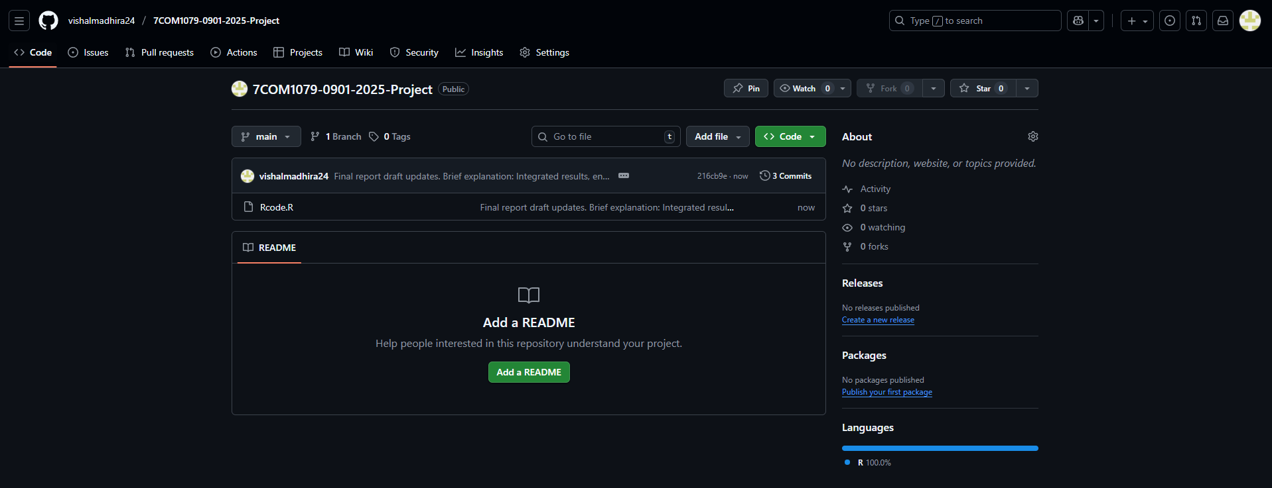

Github Link: https://github.com/vishalmadhira24/7COM1079-0901-2025-Project

